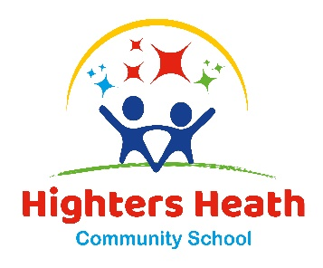
Highters Heath Community School

Highters Heath Lane Headteacher: Mrs J.Aulton
Birmingham Tel: 0121 464 2459
B14 4LY Email: office@hightersheath.co.uk
Website: www.hightersheath.co.uk

14th November 2022

Dear Parents /Carers,

We have been provided with an amazing opportunity for our Year 6 pupils to take part in a workshop called 'Precious Lives' on Friday 18th November. This is a free workshop fully funded by the West Midlands Police and Crime Commissioner. The Precious Lives workshop has been running since 2010 and is delivered as a one hour workshop.

Topics covered are:
Choices, decisions and consequences of knife crime
Exploring why young people could feel the need to carry weapons
The legal ramification that can come with that choice
Explore the term "Joint Enterprise" and what that could mean to them.

As you are aware knife crime is a topic that is of huge importance and with the current level of incidents being reported in the city, having these discussions and educating pupils on the choices, decisions and consequences of knife crime has never been more important.

The 'Precious Lives' trainers share their real-life experiences and pass on the lessons they have learned either as a victim, offender or professional to help pupils understand the consequences of carrying or using a knife. The workshops are designed to be impactful with an emphasis placed on connecting with pupils and delivering a clear message.

Thank you for your continued support.

Mrs Aulton
Headteacher

