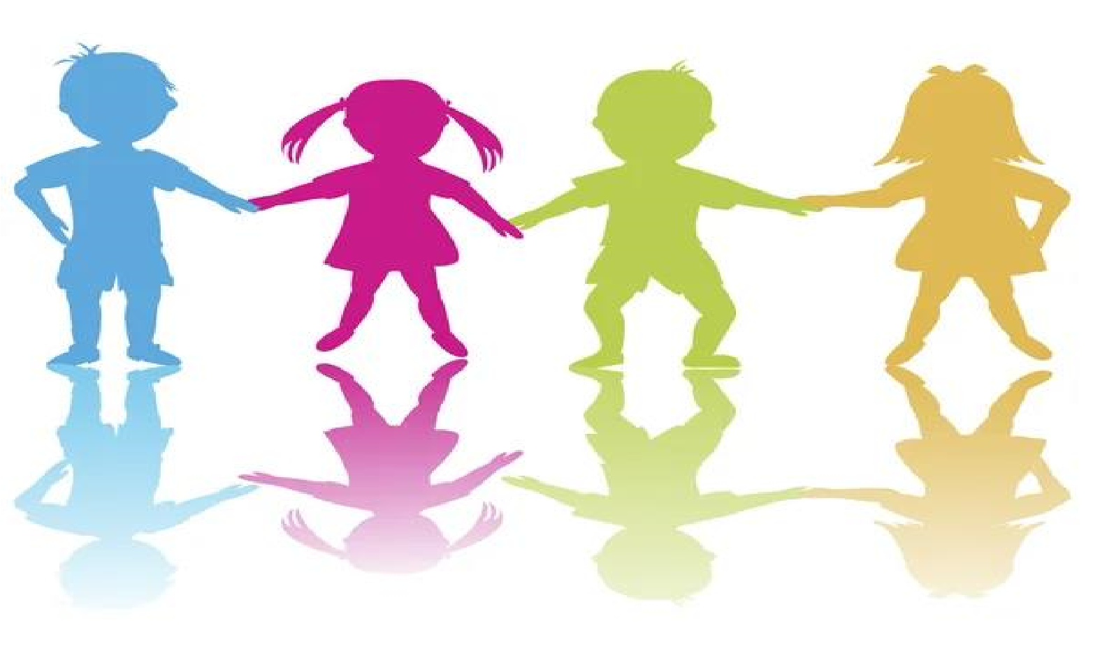
What is safeguarding?

It is everybody looking after your health, safety and welfare
:
keeping you safe
.

Highters Heath Community School School

Child Friend
ly

Safeguarding
Policy

How do we safeguard you at Highters Heath Community School?
- We know what our roles and responsibilities are to keep you safe.

- We take all concerns seriously and report them properly.

- We talk to other people about any concerns to try to find the best way to help you and your family.

- We check out anything that might be dangerous to you in school, or during activities out of school and make a plan to make these less dangerous.

- We have assemblies, lessons and awareness weeks where we learn about safeguarding such as privacy, safe touch, e-safety and anti-bullying.

- We treat everyone fairly with dignity and respect.

What do you need to understand about safeguarding?
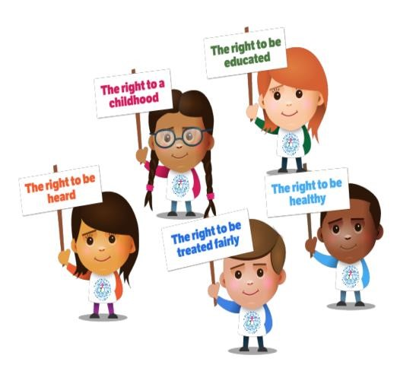

•

All adults will listen to what you have to say
.

•

Adults
may ask you questions
. If they are

worried about your safety, they might
ask

someone else
to talk to you.

•

Adults
will
never stop
you

from freely

talking
about significant events
.

You have
:

- Adults will write down what you say to make sure that we do not miss any information.

- Adults will not promise to keep secrets. They will explain that they have a responsibility to report what has been said to someone else if they are worried about your safety or the safety of somebody else.

- All adults will immediately tell the Safeguarding Team if they are worried about your safety or the safety of somebody else.

The Safeguarding Team at
Highters Heath Community School

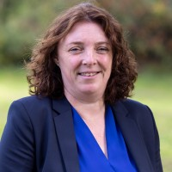
Mrs F. Lindsay  AHT  SENCO  Lead DSL | Mrs J. Aulton  Headteacher  Deputy DSL | Mrs V. Delves AHT  Deputy DSL

What should you do if you need to speak to somebody?
Speak to an adult at school if you are worried about something, it could be your teacher, a teaching assistant or a dinnertime supervisor.

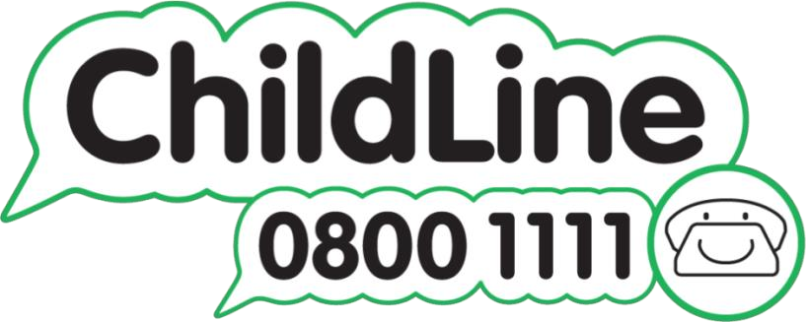
Childline is a free to call and confidential service where you can talk about anything that is worrying you.

