**Highters Heath Community School**

**Equality Report 2023/24**

**Introduction**

Highters Heath Community School is committed to the Equality Act 2010 which provides a single, consolidated source of discrimination law, covering all the types of discrimination that are unlawful. We aim to enable all pupils to take part as fully as possible in every part of school life by developing each child's self-confidence, recognising their strengths and encouraging them to achieve their full potential. We take steps to advance equality of opportunity, foster good relations and eliminate discrimination or harassment across all the protected characteristics:

* age;
* race (including colour, nationality and ethnic origins);
* gender reassignment;
* disability;
* marriage or civil partnership;
* religion or belief;
* pregnancy or maternity
* gender; or
* sexual orientation.

**Public Sector Duties**

A school must, in the exercise of its functions, give due regard to the need to (in relation to protected characteristics above):

1. Eliminate discrimination, harassment, victimisation and any other prohibited conduct.

2. Advance equality of opportunity (remove or minimise disadvantage; meet people's needs; take account of disabilities; encourage participation in public life).

3. Foster good relations between people (tackle prejudice and promote understanding).

In practice, ‘due regard’ means giving relevant and proportionate consideration to the duty, so decision makers in schools must have due regard when making a decision, developing a policy or taking an action as to whether it may have implications for people because of their protected characteristics.

**What does the population of our school look like?**

1. ***High Deprivation***

In February 2023, the proportion of Ever 6 FSM was %?? which is twice the national average of 22.5% (June 2022). We also have a significant number of families who do not qualify for Pupil Premium but for whom making ends meet on a weekly basis is a struggle.

1. ***Predominantly EAL***

22% of children have English as an additional language, with 17 different home languages in the school.

|  |  |  |  |  |  |  |  |  |  |  |  |  |  |  |  |  |  |  |  |
| --- | --- | --- | --- | --- | --- | --- | --- | --- | --- | --- | --- | --- | --- | --- | --- | --- | --- | --- | --- |
| Albanian/Shqip | Arabic | Arabic and Arabic (Any Other) | Arabic and Arabic (Yemen) | Arabic and English | Dutch/Flemish | English | English and Hindko | English and Other Language | English and Romanian; Moldavian; Moldovan | English and Urdu | Gujarati | Hindko | Kurdish | Pahari (Pakistan) and Pashto; Pushto; Pakhto | Pahari (Pakistan) and Urdu | Pashto; Pushto; Pakhto | Romanian; Moldavian; Moldovan | Tamil | Urdu |
| 1 | 12 | 1 | 1 | 4 | 1 | 138 | 1 | 1 | 2 | 2 | 1 | 1 | 2 | 1 | 1 | 1 | 4 | 3 | 10 |

1. ***Significant Mobility***

This table shows the number of mid-phase admissions and leavers over the past two years.

|  |  |  |  |
| --- | --- | --- | --- |
|  | ***2021/22*** | ***2022/23*** | ***2023/24 (to June 24)*** |
| *Joiners* | 76 | 53 | 21 |
| *Leavers* | 55 | 52 | 38 |

Of our current KS2, over {{percentage}} have arrived within the last 3 years.  There are many factors that affect this including: families moving to this country and moving accommodation regularly.

1. ***Ethnically Diverse.***

A proportion of children were born outside the UK with over 25 identified ethnicities.

|  |  |  |  |  |  |  |  |  |  |  |  |  |  |  |  |  |  |  |  |  |  |  |  |  |  |  |  |  |  |
| --- | --- | --- | --- | --- | --- | --- | --- | --- | --- | --- | --- | --- | --- | --- | --- | --- | --- | --- | --- | --- | --- | --- | --- | --- | --- | --- | --- | --- | --- |
| Sri Lankan | Afghan | Arab Other | Asian and Any Other Ethnic Group | Asian and Black | Bangladeshi | Black - African | Black - Nigerian | Black Caribbean | Croatian | Gypsy / Roma | Indian | Information Not Yet Obtained | Iraqi | Mirpuri Pakistani | Moroccan | Other Asian | Other Pakistani | Pakistani | Chinese | Roma | White - British | White - English | White and Any Other Asian Background | White and Black African | White and Black Caribbean | White and Indian | White and Pakistani | White Eastern European | Yemeni |
| 2 | 5 | 4 | 10 | 1 | 4 | 7 | 4 | 5 | 1 | 2 | 5 | 2 | 2 | 4 | 1 | 4 | 17 | 30 | 1 | 1 | 97 | 87 | 8 | 1 | 8 | 1 | 2 | 7 | 5 |

1. ***Religion***

Religion plays an important role in the lives of most children with the vast majority of families 76.8% identifying as having no religion. 19.3% of families identify as Muslim which is the next biggest group.

|  |  |  |  |  |  |  |  |  |  |  |
| --- | --- | --- | --- | --- | --- | --- | --- | --- | --- | --- |
| Roman Catholic | Christian | Hindu | Jehovah's Witness | Muslim | No Religion | Not Specified | Sikh | Refused | Anglican/Church of England | Orthodox Catholic/Eastern Orthodox |
| 0 | 21 | 3 | 0 | 36 | 20 | 123 | 0 | 1 | 1 | 2 |

**6) *Gender***

Highters Heath Community School has a balanced pupil population in terms of gender. There are four male members of staff which forms only 16% of the staff population.

**How does the school promote equality of opportunity?**

Our aim is that all who come to Highters Heath Community School will find it to be a welcoming and comfortable environment where people are treated with dignity and respect. We do not tolerate incidents of discrimination, harassment and victimisation and will deal with such incidents swiftly and decisively as and when they occur.  We want our school community to be a welcoming and comfortable environment for all who come here.  We want to foster an open environment where people feel they are being treated with dignity and respect and aim to be sensitive to the different needs of our pupils and families.

**How does the school eliminate unlawful discrimination, harassment and victimisation – as defined by Equalities Act 2010**

|  |  |
| --- | --- |
| **Aim** | **Actions** |
| To implement a behaviour policy that is clear about importance of respect for all. | We revisit rules, rights and responsibilities with children regularly, with explicit reference to respect, tolerance and equality.  Rare incidents of discrimination, harassment and bullying are dealt with swiftly in line with the behaviour policy, and recorded on Integris.  All incidents involving racist, sexist,  homophobic or other discriminatory language are treated seriously, recorded and have appropriate consequences applied. |
| To monitor and analyse student behaviour trends | CPOMs is used to monitor behaviour across the school,  including identifying trends on a termly basis.  Incidents of bullying are very rare, as are racist, sexist or homophobic behaviour. Where incidents occur, these have been addressed on an individual and year group level by the leadership team and pastoral team.  Information about behaviour patterns are shared with the governing body through the Headteacher’s Report. |
| To ensure that Highters Heath Community School is an equitable workplace. | Clear guidelines for complaints against staff, including claims of discrimination. There have been no reported cases of discrimination against staff, but if there were, HR procedures are in place for immediate action and recording.  Appropriate recruitment procedures are in place, including ensuring staff responsible for recruiting are Safer Recruitment trained.  The school takes steps to ensure that pregnancy and maternity leave is no barrier to career advancement. |
| To ensure that pupils have an age appropriate understanding of the Equalities Act and protected characteristics. | Pupils are aware of victimisation and discrimination through the anti-bullying policy and PSHE sessions.  The exceptionally low number of racist or homophobic incidents is evidence of the success of this approach.  A newly designed SRE curriculum which is to be introduced in the summer term explicitly addresses gender, sexuality and non-binary issues at an age appropriate level. |
| To reduce bullying and harassment: | Link to anti-bullying policy <https://www.hightersheath.excelsiormat.org/assets/Documents/Policies/Anti-Bullying-Policy.pdf> is reviewed annually.  Assembly themes promote anti-bullying  Regular PSHE lessons, in addition to class and year group assemblies to pre-empt problems and tackle issues arising. |

**How does the school advance equality of opportunity**

|  |  |
| --- | --- |
| **Aim** | **Actions** |
| Actively promote social and emotional wellbeing for all children. | Developed an improved admissions system, including buddy systems and family meetings.  Maintain a highly effective Pastoral Team to ensure the pastoral needs of children and families are met.  Run social skill intervention groups.  A range of free after-school clubs to provide a broader curriculum experience. |
| To ensure that staff have a good understanding of the Equalities Act and protected characteristics. | Review of policies and practical application in INSET, staff meetings. All staff are aware of the Equality Act 2010 and understand that Highters Heath Community School is committed to a culture of inclusion.  Training and awareness raising about discrimination and bullying issues. |
| To ensure that diversity is promoted in Highters Heath Community School population. | We produce a workforce census annually.  Data from the workforce census is scrutinised by Excelsior Multi Academy Trust. At Highters Heath Community School it is recognised that a diverse workforce can bring benefits in promoting opportunity, fostering good relations and prohibiting harassment:  The school administers a non-selective approach to admissions. |
| Ensure that all children and staff have full access to school life, and curriculum opportunities. | https://www.hightersheath.excelsiormat.org/assets/Accessibility-Plan-July-2021.pdf  Reasonable adjustments are made to reduce or eliminate the barriers to children with disabilities, SEN or any protected characteristic. |
| To support children and families with English as an additional language. | We assess and support children with EAL using the Birmingham EAL continuum.  A designated member of the pastoral team supports children and families new to the school.  Google Translate has been set up on the school website for the translation of important letters, website pages and documents. We have a multilingual staff used for translating and use a buy-in translation service when needed. |
| To ensure that pupil outcomes are high for all groups, particularly those with protected characteristics. | Pupil premium are targeted through quality first teaching.  Pupil data is examined in terms of gender and ethnicity and action taken to address gaps. |

**How does the school foster good relations between those who share a protected characteristic and those who do not?**

|  |  |
| --- | --- |
| **Aim** | **Actions** |
| To give all children and families a voice | Multiple avenues for children to express concerns, including through the learning mentor and outside agencies such as Malachi.  Pupil Parliament, Play Leaders and Playground Monitors provide peer support.  Time is given in the curriculum for children the chance to discuss key issues, including those around equality.  Regular workshops for families, where questions and discussion is invited.  In addition to the opportunity to visit the school at different times and take part in regular consultation meetings, parents and carers have the opportunity to share their views on the school through questionnaires and parent workshops. |
| To promote British Values: | Staff member with a responsibility for British Values built into the curriculum overview and time is given for reactive lessons where needed.  Assembly time is devoted, including class, year group and whole school assemblies.  Displays highlight the importance of British values. |
| To ensure that children of all groups have aspirational role models and positive self image. | Pupils celebrate cultural diversity and learn about discrimination through daily assemblies (including assemblies and class work about British Values) and the PSHE curriculum.  The school staff, of a range of ethnicities, help towards the provision of positive role models to children from protected groups.  Books and resources from other cultures are actively sought, explored and enjoyed. |
| To create strong community links: | Engagement with other schools, in the local area and in the trust.  Working in partnership with local nursery and children’s centre and the local secondary school.  Work experience opportunities for local secondary pupils  Visitors from local and national charities / initiatives.  Visits from Community Police Officers  Local library visits  Opportunities for employment and volunteering to create career pathways for residents in the local community. |
| To ensure children have a broad and balanced understanding of cultural ideas, religion and belief | A carefully planned RE curriculum which encompasses the major world religions and beliefs.  Whole-school sharing assemblies are held termly, to bring together key ideas from across the RE curriculum.  Cultural and religious difference are discussed and celebrated in lessons.  Visits to local places of worship, from a range of religions.  Regular discussions where links are made between beliefs. |
| To work in partnership with parents. | Workshops in English and Maths  SRE workshops, supporting parents’ understanding of curriculum and teaching approach.  Online Safety workshops  Coffee Mornings  Parents Evening  Parents attending library visits with school |

**Equality Objectives**

The Equality Act 2010 requires schools to publish specific and measurable equality objectives. Our objectives are based on our analysis of data and other evidence. Our equality objectives focus on those areas where we have agreed to take action to improve equality and tackle disadvantages. We will regularly review the progress we are making to meet our equality objectives.

|  |  |
| --- | --- |
| Objective | Actions |
| 1. **To explore and  promote positive mental health for children, including ensuring that children see the value in their own gender, cultural and religious background.** | Development of Mental Health Team with designated lead.  Revision and implementation of PSHE, RE and SRE curriculum.  Planned and targeted assemblies at class, year group and school level.  Staff training. |
| 1. **To improve awareness of gender equality, with a specific focus on addressing low-level harassment related to gender.** | Change of behaviour monitoring to better identify incidents.  Explicit, age-appropriate, teaching regarding gender equality.  Learning mentor support for key pupils. |
| 1. **To continue to monitor and  the achievement and attainment of all groups, identifying and narrowing any gaps.** | Ongoing termly monitoring of summative assessment data by pupil characteristics.  PPMs to continue focussing on narrowing gaps through targeted support / interventions  Focused family support for key pupils from the Pastoral team. |
| 1. **To continue to build a sense of community for children and parents, increasing opportunities for families to be involved in the life of the school.** | Continued use of parent workshops and discussion forums.  Development of social media.  Increase in planned opportunities for families to be invited into school and involved in learning, especially as a resource.  Increase in whole school events involving parents. |

**Current attainment (2022/23)**

**KS2**

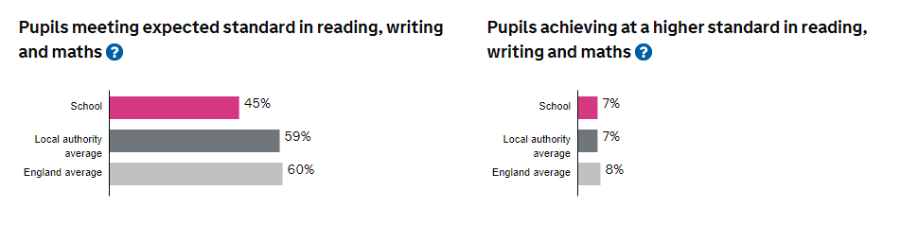

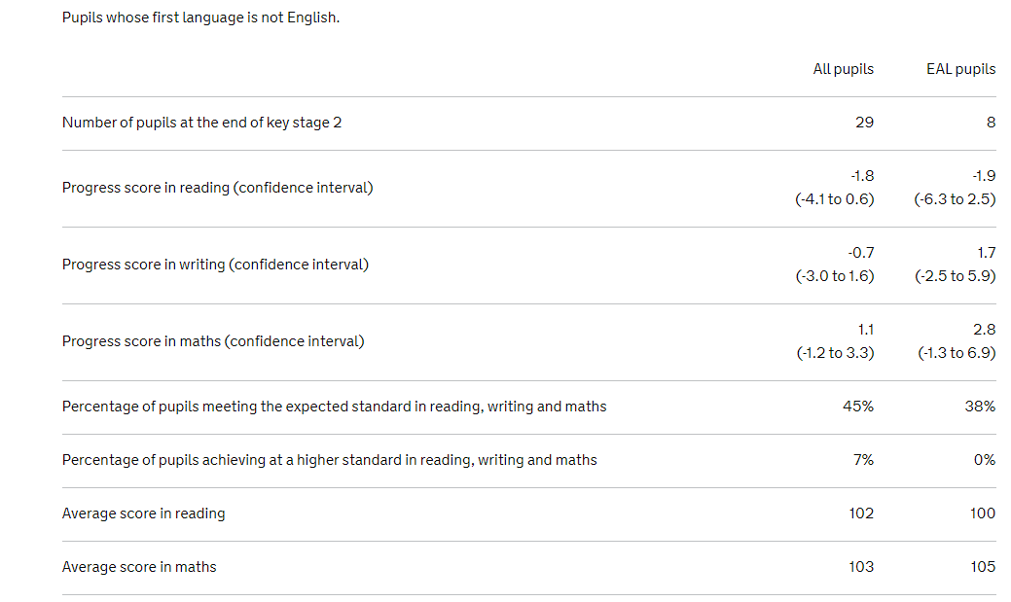

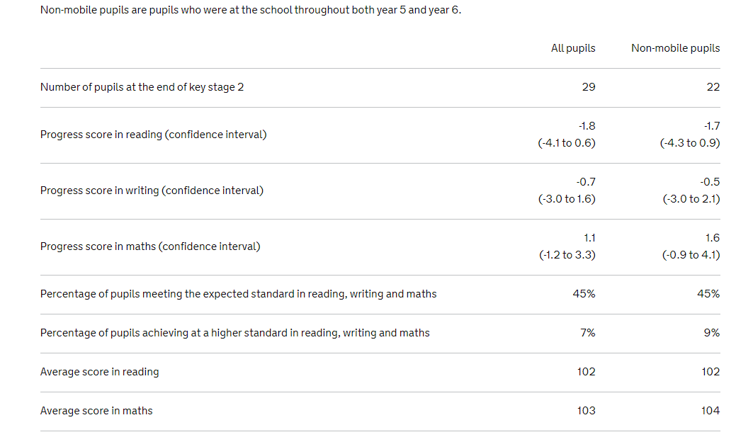

**APPENDIX 1: Public Sector Equality Duty Statement**

1.1 This statement describes how the Governing Body at Highters Heath Community School intends to fulfil its responsibilities under the Publish Section Equality Duty with regard to its workforce. The equality objectives will form part of the accessibility plan and the information will be published.

1.2 We will have a due regard to the need to:

* eliminate unlawful discrimination, harassment, victimisation and any other conduct prohibited by the Equality Act;
* advance equality of opportunity between people who share a projected characteristic and people who do not share it; and
* foster good relations between people who share a protected characteristic and those who do not share it.

1.3 We will collect and use equality information to help us to:

*Identify key issues*

* understand the impact of our policies, practices and decisions on people with different protected characteristics, and thereby plan them more effectively;
* assess whether we are discriminating unlawfully when carrying out any of our functions;
* identify what the key equality issues are for our organisation.

*Assess performance*

* benchmark our performance and processes against those of similar organisations, nationally or locally.

*Take action*

* consider taking steps to meet the needs of staff who share relevant protected characteristics;
* identify if there are any actions we can take to avoid discrimination and harassment, advance equality opportunity or foster good relations;
* make informed decisions about policies and practices which are based on evidence about the impact of our activities on equality;
* develop equality objectives to meet specific duties;
* have due regard to the aims of the general equality duty by ensuring that staff have appropriate information for decision-making.

1.4 We will work towards developing an equality profile of staff to help us to understand key equality issues in our workforce, including any evidence of pay gaps or ‘occupational segregation’ i.e. staff with certain protected characteristics being over-represented in particular roles, for example, women as cleaners, or at certain grades. In addition, we note that it is likely to be useful to collect and consider information, appropriately disaggregated, about:

* recruitment and promotion
* numbers of part-time and full-time staff
* pay and remuneration
* training
* return to work of women or maternity leave
* return to work of disabled employees following sick leave relating to their disability
* appraisals
* grievances (including about harassment)
* disciplinary action (including harassment)
* dismissals and other reasons for leaving

**2 Publication of Equality Information**

We will collect and use enough workforce information to effectively meet the general equality duty. Where relevant and proportionate we will publish information about the impact of our employment functions on people with the different protected characteristics in order to demonstrate compliance with the general equality duty.

References

* Equality Act 2010
* What Equality law means for you as an education provider-schools, Equality and Human Rights Commission
* Schools Admission Code, DfE
* Equalities Mediation Service (EMS)

***To be reviewed: June 2025***