**Highters Heath Community School**

**Newsletter**

**Friday 1st December 2023**

**Dates for your Diary**

**Monday 4th December – SEND Parents Meetings by invitation**

**Tuesday 5th December – SEND Information Report Parents Meeting**

**Thursday 21st December – Year 4 Visit to the Old Rep to see Peter Pan**

**Thursday 21st December – School closes at the normal time of 3.15pm for the Christmas holidays**

**Teacher Training Day – Friday 22nd December**

**Teacher Training Day – Monday 8th January**

**School reopens – Tuesday 9th January at the normal time of 8.45am**

**Monday 22nd January – Year 2 Stone Age Workshop**

**Friday 9th February – School closes at the normal time of 3.15pm for half term**

**Monday 19th February – Teacher Training Day**

**Message from the Headteacher**

Happy December! On Monday we had a MAT Maths review. Helen Hackett Maths Lead for Excelsior Multi-Academy Trust and Eleanor Hill Maths Lead from Colmers Farm Primary School came to join us for the day. They spent time in all the classes and were really impressed with the children’s maths skills and could clearly see how far as a school we have come. We are always striving to improve, and I am honoured to have such a wonderful team of staff who always want the best for your children. I can’t thank them enough for all their hard work and dedication.

The work on the roof is now complete and we are hoping the scaffolding will come down over the weekend too. We also have more building work planned to include new flooring and carpet in the corridors, sanding and varnishing of the main school hall floor, and tarmacking of parts of the KS1 playground. We are hoping this will be completed over the Christmas holidays.

As always if you have any questions or queries, please contact the school office using the enquiry email. [enquiry@hightersheath.excelsiormat.org](mailto:enquiry@hightersheath.excelsiormat.org)

Thank you for your continued support,

Mrs Aulton

Reception had a wonderful time with Chip the storyteller this week. They enjoyed looking at books, sharing their favourite stories and listening to stories through songs. We hope they continue to share their loves of books at home. Thank you, Chip, – we look forward to seeing you again really soon.

On Monday Year 6 went on a trip to St Chad’s Cathedral. The children explored both the crypt and the main cathedral building itself. They heard about the history of St Chad and how the cathedral came to be built, as well as about the architect who designed it, Augustus Pugin. They learnt how he was part of a duo who designed the Houses of Parliament and The Elizabeth Tower that houses the Big Ben clock! They had a tour of the beautiful building and saw the stunning stained-glass windows. The children were extremely well behaved and respectful to their tour guides during the visit and enjoyed hearing about some of the history of the Catholic faith and their worship.

**Year 6 Visit to St Chad’s Cathedral**

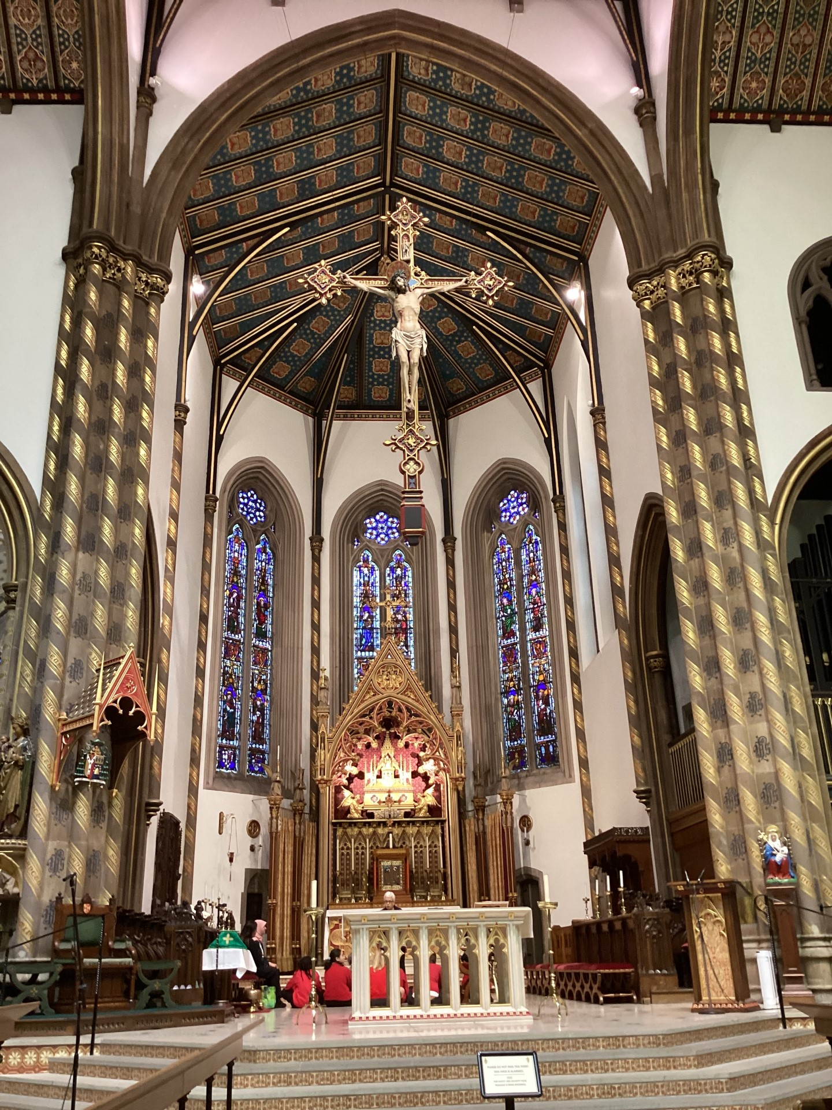

**Chip the Storyteller visits Reception**

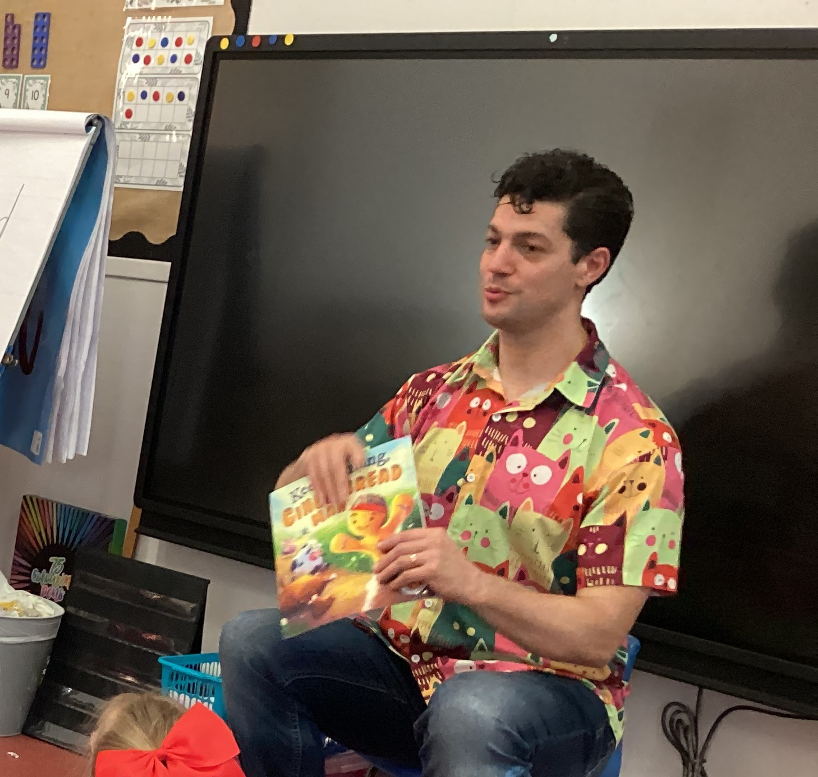

.

|  |
| --- |
| Brrrrr! The weather has certainly taken a cold turn this week and with winter weather comes coughs and colds. We have seen a big decline in our attendance this week and a number of parents have been informing us that this is because their child has a cough or a cold. Please don’t keep your child at home just because they have a cough or a cold. You should only keep your child off school if they are unwell. Similarly, a tummy ache is not a valid reason to keep your child off school. Often a dose of liquid paracetamol or ibuprofen before school may be all they need to help them feel well enough to attend. If your child does need to be off school due to illness, please can we ask that you phone school before 9.30am. If we don’t hear from you with a reason for your child’s absence a home visit will be carried out.  If you are having difficulties getting your child to school and would like any support, please contact Mrs Lindsay.  **Spotlight on Attendance** |



**Hot Chocolate Friday Winners**

Congratulations this week go to:

Reception Mowafak

Year 1 Mumin

Year 2 Haaris

Year 3 Phoebe

Year 4 Winner

Year 5 Jacob

Year 6 Jessica

I look forward to meeting even more children who have gone above and beyond and have been nominated for this award.

**Celebration Assembly Award Winners**

This week’s winners are:

Reception Arthur and Ralphie

Year 1 Ezekiah and Winner

Year 2 Evie-Leigh and Elsie

Year 3 Subhan and Phoebe

Year 4 Haseeb and Winner

Year 5 Thomas and Caelan

Year 6 Luqman and Winner

Congratulations to everyone who won a Headteachers Award this week.

**House Points**

Well done to everyone receiving house points this week. The winners are…

Apollo Mercury Neptune Pegasus

2981 2875 2928 2829

Well done to Apollo for achieving the most house points this week.

**Attendance**

Well done to everyone who has tried really hard with their attendance this week. As always, school attendance is important for your child, both in terms of their education as well as for their well-being and life opportunities.

Our attendance this week

Reception 76.2%

Year 1 91.3%

Year 2 86.5%

Year 3 86.5%

Year 4 93.8%

Year 5 98.3%

Year 6 91.1%

Whole School 88.4%

Please can you ensure your child attends every day where possible and is on time for school – doors close at 8.55am.