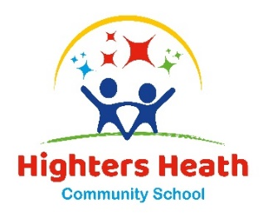
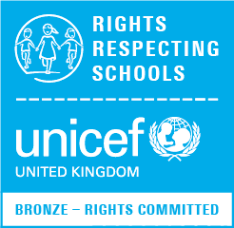
Highters Heath Community School

Highters Heath Lane Headteacher: Mrs J.Aulton
Birmingham Tel: 0121 464 2459
B14 4LY Email: office@hightersheath.co.uk
Website: www.hightersheath.co.uk

20th July 2023

Dear Parents

We recently invited you to complete our Relationships Education Parent Consultation and would like to thank you for taking part.

Thank you to everyone for your considered response. It has been reassuring to know that the presentations have been well received and feedback suggests the explanations over the slide shows added value and clarity regarding the changes to the curriculum.

The overall response to the proposed changes has been extremely positive. Parents and carers have shared that they have read the guidance and have listened to the presentations and have felt secure in what their child will be taught in each year group. Feedback regarding our choice of curriculum support materials (No Outsiders) has also been positive. Following the consultation, the proposed Relationships Education curriculum has been approved by our Governors and will be taught from September.

You will be invited to the first No Outsiders lesson of the school year and are welcome to view the resources in school.

As a school community we are committed to working in partnership with parents, carers and all stakeholders within it and, as such, your feedback is invaluable. We have responded to all the questions raised by parents on the following page.

If you have any questions or queries or would like to view the resources, please feel free to contact me via the school office.

Thank you for your continued support,

Mrs Aulton
Headteacher

Question | Response
Why do we have to teach about relationships so early on in Reception and Year 1? | We have to teach children about different families under the Department for Education requirements. We teach this in a non-threatening way through picture books from an early age so children know there are differences.
Can we withdraw our children from lessons? | Relationships Education is part of the National Curriculum and so children cannot be withdrawn from these lessons.
Why do the books have two Mums as this will confuse the children? | Our lessons show children that there are many different types of family. It is important that all children and families are represented in the books we use. The story does not reference the relationship between the mums.
Why is the man naked in The Island? | This is to show that he has lost everything, even his dignity.
Introducing Teddy – How far does the discussion about transgender go? How much do the children really need to know? | We do not discuss transgenderism. We talk about how we can make everyone feel accepted and welcomed for who they are.
What are the resources used to teach sex education? | There will be a separate consultation for Sex Education. All the resources and lesson plans will be shared, and parents can withdraw their children from those lessons.
Will sex education lessons be single gender?

How will sex education lessons be taught?

Will parents know what is being taught and when during sex education lessons?
Would we show videos in Sex Education lessons?

When do you teach about menopause and breastfeeding? | We do not teach this as it not on the National Curriculum or Relationships and Health Education expectations from the Department for Education.

