PE Funding

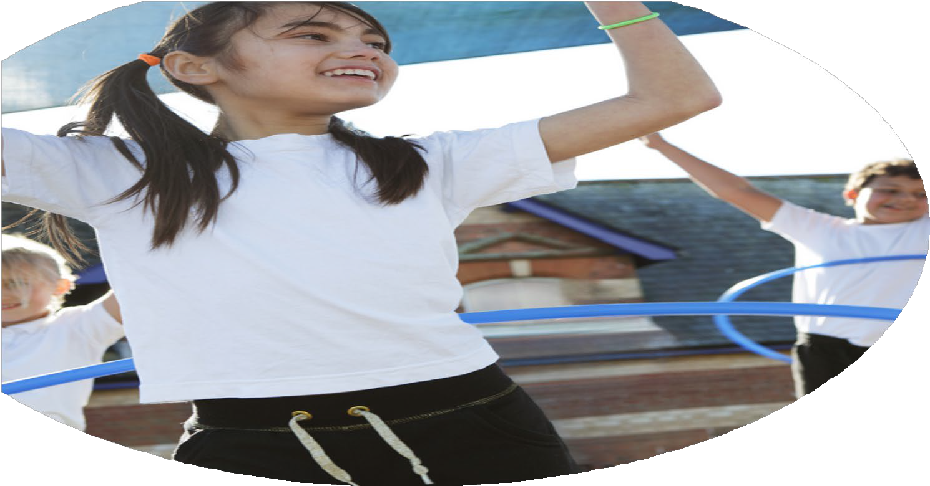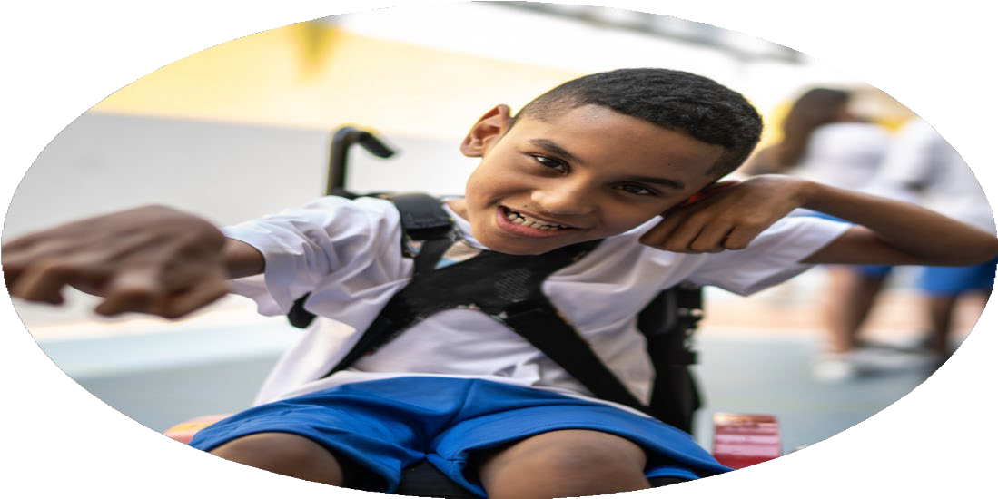

Evaluation Form

**Commissioned by**

**Created by**

Images courtesy of Youth Sport Trust

**PE Funding Evaluation Form**

 It is intended that this template should be used as preparation for the completion of the statutory digital reporting tool being introduced this academic year. You can upload data (including swimming) from this template onto this platform once it becomes accessible.

 Before you decide how you are going to use the funding for this academic year you should reflect and evaluate the impact of your use of the funding in 2023/24.

 All spending of the funding must conform with the terms outlined in the Conditions of Grant document.  The template is a working document that you can amend/update during the year.

 Based on your evaluation of last year’s funding you should decide what you intend to do this academic year, how you will do it, and what impact you expect it to have.

It is important that the funding is used effectively and based on your school’s needs.

 You must use the funding to make additional and sustainable improvements to the PE and sport in your school.  You must develop and add to the PESSPA activities that your school already offers.

*Summative digital reporting from June 2025 will continue to include swimming and water safety information therefore funding can be used to provide top-up lessons where necessary to ensure pupils meet national curriculum swimming requirements.*

**We recommend that you start by reflecting on the impact of current provision and reviewing your previous spend**

2024-25

|  |  |  |  |
| --- | --- | --- | --- |
| What went well? | How do you know? | What didn’t go well? | How do you know? |
| * Use of sports coach to deliver PE lessons and after school clubs. * CPD for sports coach.   (Tennis, gymnastics, basketball, dance, football, OAA)   * Use of KDDK company to support CPD and deliver gymnastics, dance and yoga lessons and clubs. * OPAL * Interschool competitions. * New resources * Warwickshire Cricket Company * Aston Villa Football Club * Bikeability | * Increased participation and engagement in lessons and after school clubs. * Sports coach has better knowledge and understanding of how to deliver a range of different sports. * Improved engagement and participation in clubs and teacher knowledge. * More active playground for all. * Increased participation in competitive sports- including girls and SEND * New resources meant children were more engaged as the equipment was new and suitable to learning. * Children really engaged with the cricket coaches and more children took part in the cricket after school club because of this. * Children were really engaged and enthused about a professional football club working with them.   2024-25   * More children were able to ride a bike safely on the road. | * Staffing levels meant we were unable to attend as many competitions as we would have liked to. | * Unable to attend due to staffing levels. |

2025-26

|  |  |
| --- | --- |
| What are your plans for 2025/26? | How are you going to action and achieve these plans? |
| Intent | Implementation |
| * Continue to develop the knowledge, pedagogy for the sports coach to enable them to deliver lessons effectively for all children throughout the school. * Participate in a range of sporting events including SEND Panathlon and Girls Football tournament. * Target SEND and disadvantaged children to enable them to access more of the curriculum, clubs and sporting events. * Offer more after school clubs each week. * Increase the number of children completing Bikeabilty level 2. Increase the number of children who are able to complete ‘Learn to ride’ course. * Work with the children as well as their parents to provide pathways to engaging with cricket beyond school. * Provide professional opportunities for children to engage with. | * Continue to work with the MAT PE lead to offer CPD opportunities throughout the year. Work 1:1 once a week with the sports coach. * MAT lead to support in offering opportunities to PE lead for the school to take part in a range of competitions and events throughout the year. * Provide opportunities for all children to engage in the curriculum, adapting it to suit their needs where necessary and enabling them to attend a range of sporting events, where possible. * Engage more children by offering new sports clubs, using pupil voice to do this. Use KDDK to provide opportunities for gymnastics, dance and yoga. * Book Bikeability for Spring/Summer term for Key Stage 2 children. * Engage with Warwickshire Cricket Club. * Engage with professional clubs. |

|  |  |
| --- | --- |
| What impact/intended impact/sustainability are you  expecting? | How will you know? What **evidence** do you have or  expect to have? |
| * More engagement with a larger variety of sports. * More active participation and engagement with clubs and sporting events. * Increased participation in PE lessons, clubs and events. * Children are engaged and want to develop their abilities in further sporting opportunities outside of the classroom. * Better access for all children- disadvantaged/SEND * Increased skills and knowledge for sports coach. | * There will be more children attending clubs and more clubs on offer. * Sports coach will deliver effective lessons 2 hours per week for each class. * More competitions will have been attended – shown through the School Games mark – Silver. * Pupil voice, learning walk, registers, Ofsted Reviews from MAT |

|  |  |
| --- | --- |
| What **impact/sustainability** have you seen? | What **evidence** do you have? |
|  |  |