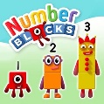

**Our theme this term**

This term, the theme for reception is ‘Marvellous Me.’ We will be finding out about who we are, our own life stories, our likes and dislikes and exploring the natural world around us.

**Personal, Social and Emotional Development:**

We will focus on making friends and learning new routines in school. We will become familiar with our classroom and school environment and develop our confidence and talk about how we are feeling. We will learn about similarities and differences between us and know that we are all unique and special.

**Understanding the World:**

We will talk about our journey to school, things we can see around us and look at and draw maps of our school. We will talk about our families and know our own life story and look at images of familiar situations in the past. We will explore the natural world around us and describe what we can see, hear, and feel (lots of links to autumn) and know that there are different countries in the world.

**Expressive Arts and Design:**

We will enjoy painting and drawing pictures of ourselves, our families and animals using more detail and, when painting these pictures, we will explore colour mixing. We will also explore and join different materials for a desired effect/design and learn and sing a range of songs and nursery rhymes.

Class Teacher – Mrs Delves

Teaching Assistant – Mrs Johnson

Welcome to Reception. We hope that your child has had a great start to the academic year and is enjoying being part of Highters Heath Community School. This newsletter contains information about your child’s learning in Reception for this term. If you have any questions we are here to help.

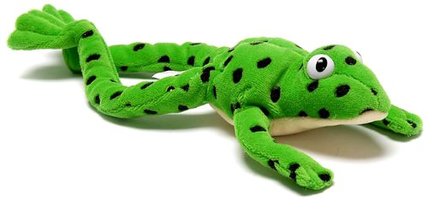

**Literacy**

We will be listening to and talking about a range of stories using a wider vocabulary and learn to name different parts of a book (title, cover, author, etc). We will learn how to write our first name forming our letters correctly and be able to write some other letters correctly. We will be able to talk about and tell others what we have drawn/written.

Your child will begin their journey in phonics, following the Read Write Inc. scheme. They will begin to learn single letter sounds and how to write the letter for each sound. We will learn how to put these sounds together to read words.

**Maths**

During our maths lessons we will play dice games to learn how to subitise (say how many are in a set without counting). We will also develop our counting skills by counting larger sets accurately saying one number name for each object in the correct order. We will explore the composition of numbers within 5 and compare sets of objects using the language of comparison.

We will be able to recognise our numbers and learn how to write

them. We will also be able to describe and make patterns and

name and describe shapes.

**How can you help at home?**

* Talk with your child about their day.
* Go for a walk around the local area and notice changes you can see around you.
* Sing songs and nursery rhymes.
* Practise learning letter sounds and how to write these letters.
* Make sure your child can read and write their own name.
* Share stories together.
* Lots and lots of talk!
* Try and do some of the home learning activities attached.

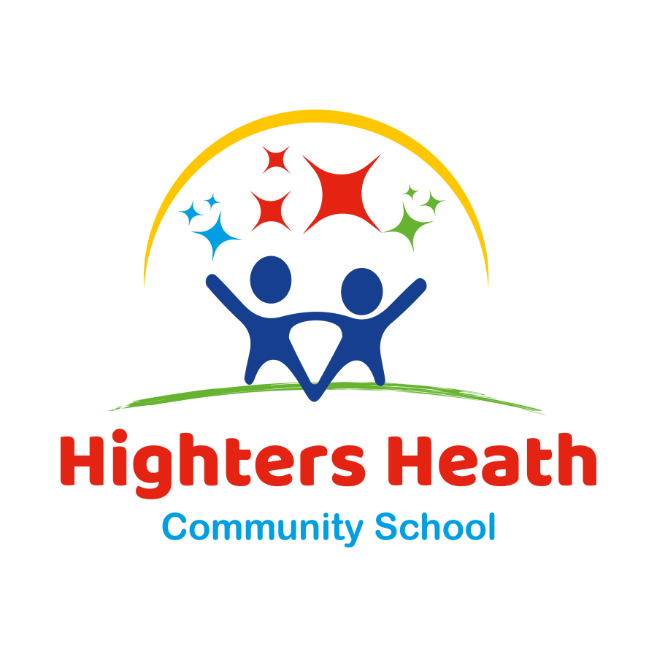

**HIGHTERS HEATH COMMUNITY SCHOOL**

**Reception Newsletter**

Autumn Term

2023 – 2024

**Class information**

P.E Day: Tuesday – please ensure your child has their PE kit in school.

P.E kit: all children should change into a plain white t-shirt and

black shorts / jogging bottoms and PE pumps.

All long hair should be tied back.

Reading books: children will bring home a story book every week from school for you to share together. These books are to aid your child in reading for pleasure. Due to the high cost of books, if a book is lost or damaged then it will have to be paid for.

Homework: attached are some suggestions for things you can do at home together to consolidate learning that is happening at school. We will also send home links with the sounds your child has learnt in phonics. Please practise these sounds every day. By the end of the week, we want your child to be able to consistently recognise, say and write each sound we have learnt.

All money sent into class should be in an envelope, clearly named with the child’s class.

In the interests of the children’s safety, jewellery is not to be worn at any time.