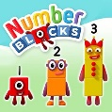

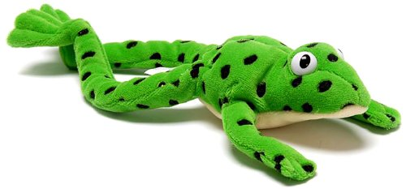

How can you help at home?

* Talk with your child about their day.
* Go for a walk around the local area and listen for different sounds. Ask ‘how’ and ‘why’ questions and encourage your child to answer these speaking in full sentences.
* Sing songs and nursery rhymes.
* Look out for different sounds in books, can you put these sounds together to read words (e.g. c-a-t makes cat). Can you write these sounds?
* Practise writing your child’s first and surname.
* Share stories together.
* Lots and lots of talk!
* Try and do some of the home learning activities attached.

Our topic this term

This term, the theme for reception is ‘Growing and Changing.’ We will be looking at how we have changed, observing the changes of the seasons, and looking at differences between animals.

Personal, Social and Emotional Development:

During this term, we will be learning to understand and talk about the importance of a healthy lifestyle. We will know that we are all unique, special, and important and we will begin to show that we can be resilient and persevere.

Understanding the World:

We will look at the changes in the seasons and observe and discuss the changes we can see in our environment. We will look at animal habitats and sort and categorise animals into where they live.

During winter, we will explore freezing and melting and look at animal life cycles during the spring.

We will think about how we have changed since we were babies and show concern for living things.

Expressive Arts and Design:

We will enjoy painting and drawing pictures of different animals with increased accuracy and detail and creating winter and spring pictures and collages. We will enjoy telling our own stories, making puppets and learning to sing a range of different songs.

Class Teacher – Mrs Delves

Teaching Assistant – Mrs Johnson

We have a busy term planned with lots of exciting learning opportunities. This newsletter contains information about what we will be learning this term. If you have any questions, please feel free to ask, we are here to help. We are also planning some more parent workshops over the next term – please look out for more details.

**Literacy**

We will continue our journey in phonics, following the Read Write Inc. scheme. We will ensure we can confidently read and write all of our single letter sounds and the special friends sh, ch, th, qu, ng and nk. We will use these sounds to read and write words.

There will be lots of opportunities for us to write in class and we will work hard to form our letters correctly and begin to ensure these letters sit on a line. We will write simple captions and phrases to match a picture and think about how sentences are constructed starting with a capital letter and ending in a full stop.

**Maths**

In maths, we will know the composition of numbers (how they are made) to 10 and know number bonds to 5 and some number bonds to 10. We will be able to say how many objects are in set to 5 without needing to count them and be able to share sets equally.

We will confidently use the language of more and fewer to compare sets and know what is one more / less than a given number.

We will be able to name 2D and 3D shapes and talk about their basic properties. We will also know and use the language related to time and capacity.

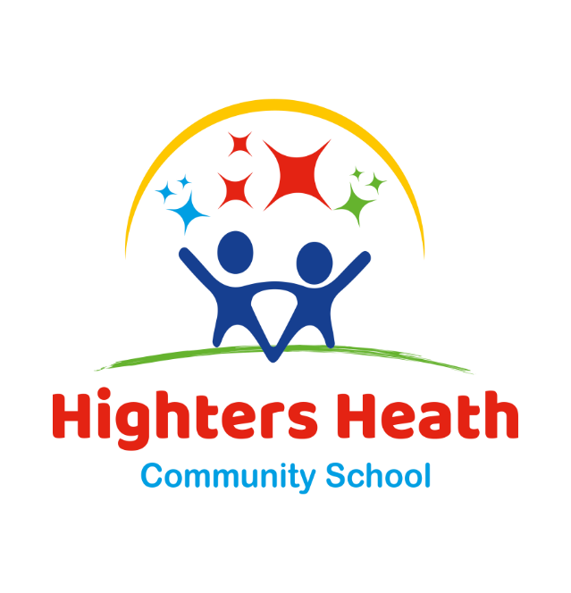

**HIGHTERS HEATH COMMUNITY SCHOOL**

**Reception Newsletter**

Spring Term

2023 – 2024

**Class information**

P.E Day: Thursday – please ensure your child has their PE kit in school.

P.E kit: all children should change into a plain white t-shirt and black shorts / jogging bottoms and PE pumps.

All long hair should be tied back.

Reading books: children will continue to bring home a story book every week from school for you to share together. These books are to aid your child in reading for pleasure. Once your child is confident at blending their sounds together, they will also bring home a phonics reading book which they will read to you. Due to the high cost of books, if a book is lost or damaged then it will have to be paid for.

Homework: attached are some suggestions for things you can do at home together to consolidate learning that is happening at school. Please also ensure your child is practicing the sounds in their green sounds book (sent home last term) and that you are sharing stories together regularly.

In the interests of the children’s safety, jewellery is not to be worn at any time.

Trips and visits:

Attwell Farm - 21st March.

Living Eggs chicks in class – between 4th and 15th March.