

Summer Term

Dear Parents and Carers,

Welcome back!

Welcome back. We hope you have all had a lovely Easter break with some well-earned rest and time spent with friends and family. This year is flying by; we can’t believe that we are in our final term of Reception! We have lots of fun learning opportunities planned this term and are excited to see how much progress we have made this year. Please keep practicing reading at home and, as always, if you have any questions or queries, we are always here to help.
Mrs Delves and Mrs Johnson.


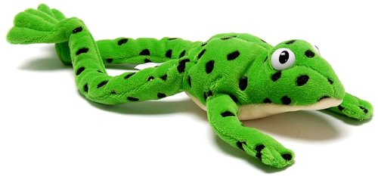
English

This term we will be focussing on reading sentences using our sound knowledge to help us. We will read words with ‘special friends,’ use ‘Fred in our head’ to read words and begin to read many words speedily. We will learn new special friends and be able to read words with these in them.
We will listen to a range of stories in class and will enjoy talking about these. We will be able to retell them in our own words using phrases from the story and enjoy making predictions about what we think might happen next.
There will be lots of opportunities for us to write in class, writing simple sentences independently using our sounds to help us to spell words. We will also be able to spell some words correctly and use capital letters and full stops in our writing.

Maths

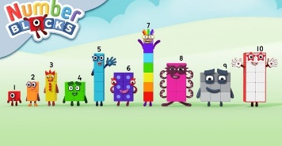
In maths, we will be able to recall the addition facts for numbers to 5 and their corresponding subtraction facts. We will also learn our number bonds to 10 and know number doubles.
We will explore numbers to 10 and how they are made and be able to say how many are in a set without counting them. We will also be able to count beyond 20, recognising the pattern of the counting sequence.
We will compare sets saying when they have more or less and recognise when quantities are the same. We will also explore and represent patterns within numbers up to 10, including evens and odds, double facts and how quantities can be shared equally.

Curriculum Theme

This term, the theme for Reception is ‘All Around Me.’ We will be looking at our immediate environment, roles and responsibilities people have and comparing where we live to different places.

Personal, Social and Emotional Development:

During this term, we will develop our confidence, resilience and perseverance and continue to form and maintain positive relationships. We will be able to follow instructions with several parts and be able to regulate our own emotions.

Understanding the World:
We will learn about the roles and responsibilities of different people and talk about people who help us. We will be able to describe features we can see around us, how these have changed over time and how they compare to different places around the world.
We will enjoy watching how seeds and plants grow and find out about different foods and traditions around the world.
We will use different stories to find out about the world and beyond and be able to talk about what we have learnt.

Expressive Arts and Design:

We will learn a range of different songs and stories about the world around us. We will be able to make up our own stories and use these in our play and retell stories using puppets.
We will enjoy drawing and painting different plants, foods, and animals and experiment with different colours, materials and designs.

Useful websites
www.hightersheath.excelsiormat.org
www.ruthmiskin.com
www.bbc.co.uk/cbeebies/shows/numberblocks

Important Dates for this term
Fire service visit to school – Tuesday 5th May.
The Animal Man visit to school – Wednesday 24th June.

Final Notices!
PE day is on Thursday. Please ensure that your child has their PE kit in school on this day. Earrings are to be removed or not to be worn on PE days and long hair needs to be tied back.

Homework – Please make sure that the children read each week and watch the phonics videos that are sent home.

If you have any queries, concerns or questions, please do not hesitate to ask. Please phone the school office or email: enquiry@hightersheath.excelsiormat.org

We hope that this term will be an exciting, enriching and rewarding term for everybody in Reception and we very much hope that you will join us in helping to make this happen.

Best wishes, and thank you in anticipation for your continued support,

Mrs Delves and Mrs Johnson

