Class information

P.E days: Thursday and Friday

P.E kit: all children should change into t-shirt and shorts / jogging bottoms and trainers or pumps. All jewellery must be removed before the lesson commences and long hair should be tied back.

Library Day: Monday

The children will not be allowed to borrow a new book unless they return the one previously loaned.

Reading books: are to be brought into school every day. Due to the high cost of books, if a reading or library book is lost or damaged then it will have to be paid for.

Homework: Homework will be set every Friday and will reflect the work that has been taught during the day. Reading is a priority and children are encouraged to read their reading books every day.

All money sent should now be paid through Arbor.

We ask that children bring water into school, and that any snacks are healthy.

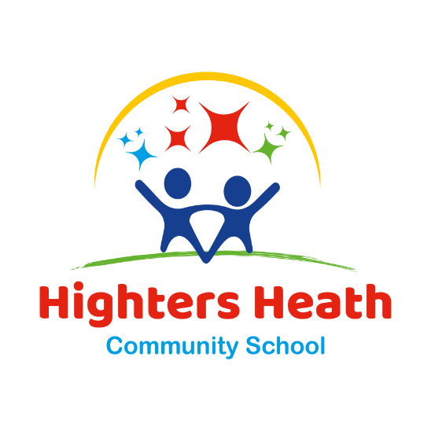

HIGHTERS HEATH COMMUNITY SCHOOL

YEAR 2 Newsletter
Spring Term
2023 - 2024
Welcome back!
Class Teacher – Mrs Towner
Teaching Assistant – Miss Morris

Welcome back to an exciting Spring Term. We have had a fantastic start to another busy term with lots of exciting and engaging learning ahead.
Our theme this term.
Our theme this term is Prehistorical Britain.

In this theme we will be focusing on the Stone, Bronze and Iron Age. We will be learning how they survived during this period and exploring how Britain has changed.
In Art we will be using charcoal to create cave paintings. We will be exploring using expression marks and use light to make subjects to create a sense of drama.
In DT we will be developing key life skills to prepare vegetables to make a healthy salad.

Gestural Drawing with charcoal-Cave designs

Maths:
This term we will be learning about identifying and counting money in pounds and pence. We will be discovering different ways to make amounts and making change from any amount.
We will also be learning about multiplication and division of 2, 5 and 10. We will be learning about equal and unequal groups and strategies to help support in solving multiplication problems.
English:
This term we have been looking at narrative texts focused around our theme topic of Stone Age. We will be learning about punctuating sentences correctly, using the correct tense and using pronouns.
Science:
This term in Science we will be learning about everyday materials. We will be learning about the different materials and how they are used to create everyday objects. We will look at their properties and explore their suitability.
RE / PD:
This term in PSHE we will be looking at the meaning of living in the wider world and the communities which we belong to. We will also explore ways to look after our world. In RE this term, we will be learning about how living in unity and harmony and gaining an understanding the meaning of stereotypes.

How can you help at home?
- Talking about different topics studied in class.
- Going to the library.
- Reading with your child daily and then, most importantly, talking about what has been read, checking your child’s understanding.
- When your child has homework encourage them to complete it and hand it in on time.
- Continue to use TTRS logins at home to further develop maths skills.
Trips and Visits.

Athlete Visit – Thursday 22nd February

